**VETCARE: ONLINE VETERINARY APPOINTMENT SYSTEM**

**FOR KINGDOM ANIMALIA**

**Admin Side**

**LOGIN PAGE** – Login page for the Administrator of the Kingdom Animalia Online Appointment System website. In this page, the Administrator will enter their login credentials then if it’s right, the admin page will appear.

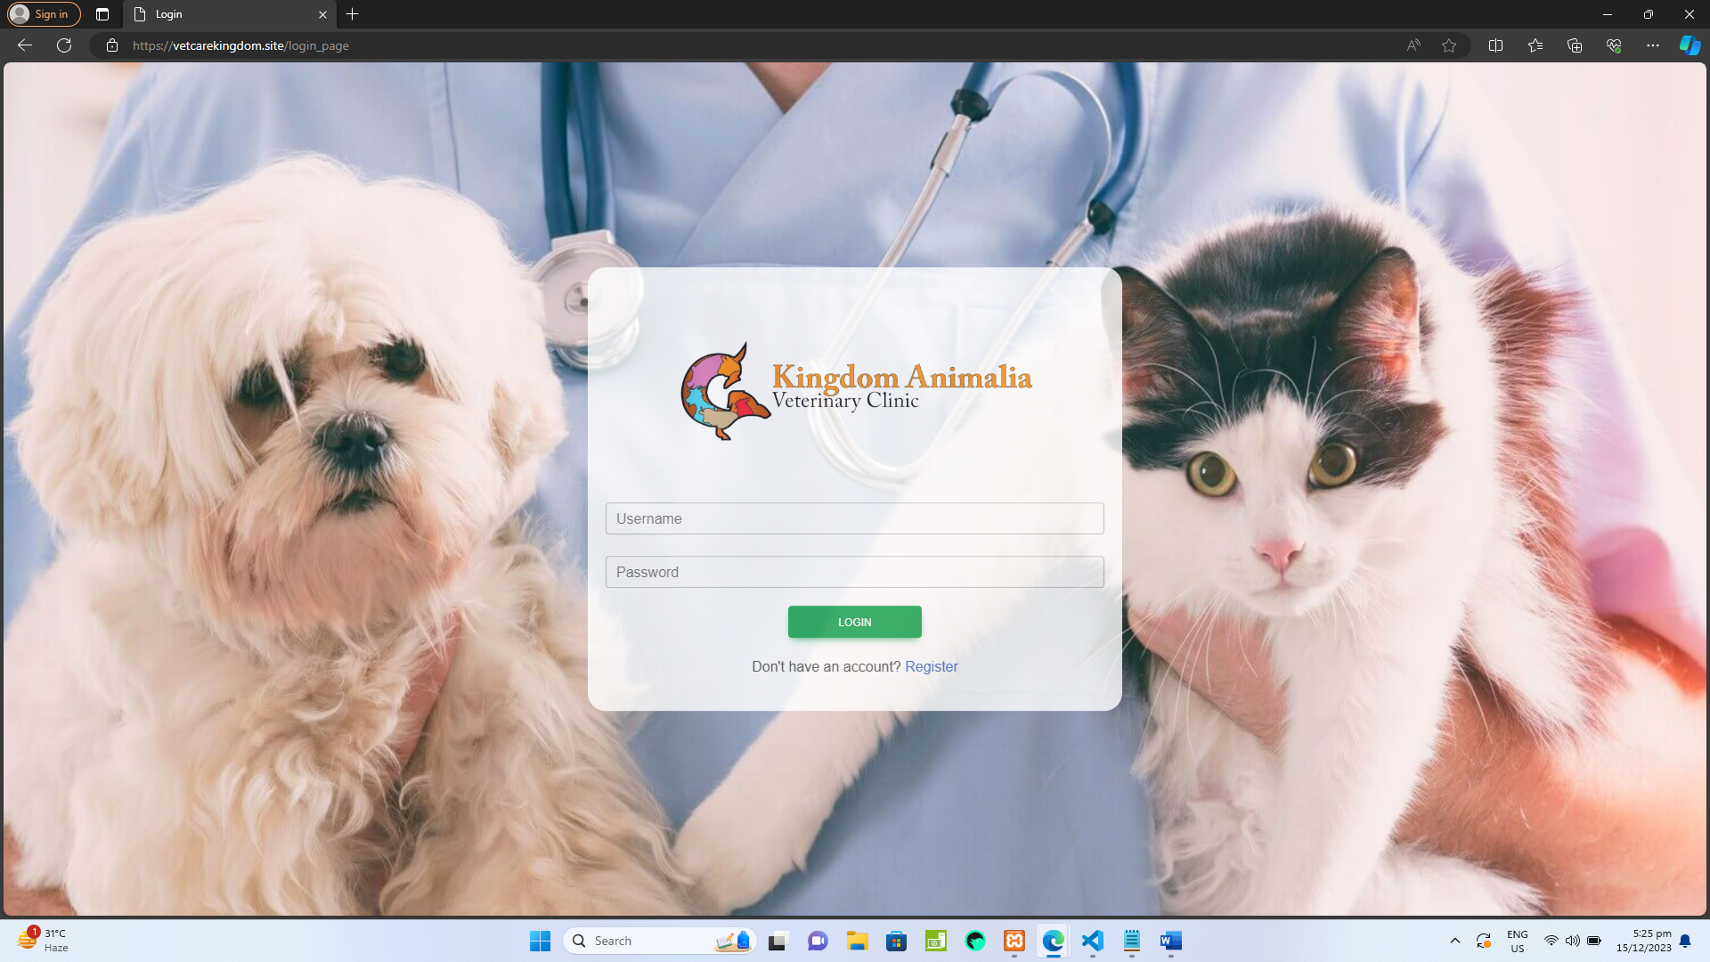

**Plate 1. Login page**

1. **ADMIN PAGE –** This page is where the Admin can control and manage all the Create, Read, Update, Delete (CRUD) functions, Appointment Requests Management, and Content Management in the website which can be seen by the clients of the Veterinary Clinic.

* **Navigating through different parts of the Admin side:**

1. **SideBar** – The sidebar shows the different titles of the contents of the veterinary website, and once you click the title then a webpage will appear where the Admin can see the records and different controls that they can use to do a certain task.
2. **Current Logged in account** – The Admin can also see the name of the currently logged in account.
3. **List of Appointments** – In this page the admin can see the list of appointments of the clients who requests an appointment.
4. **View Button** – When the admin wants to see the full details of the client who requests an appointment just click the VIEW ICON button.
5. 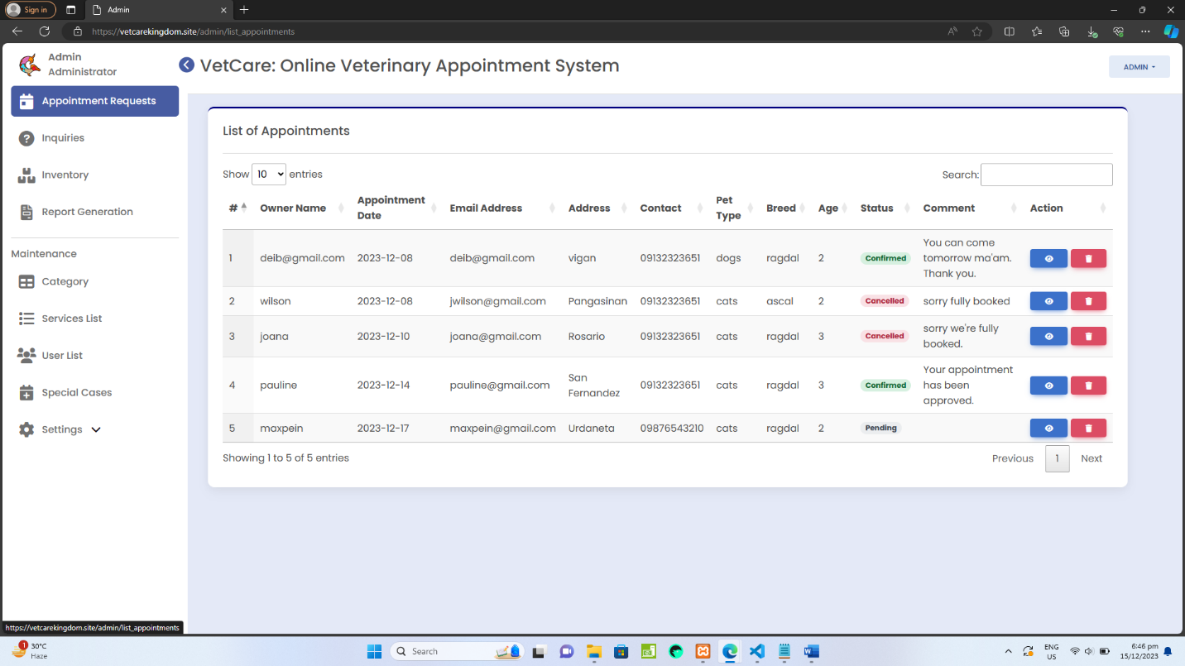**Delete Button** – If the admin wants to delete the record of the client who does not meet the scheduled date of their appointments just click the DELETE ICON button.

**Plate 2. Appointment Requests Page**

* **Appointment Requests Details page** – This page will appear once the admin clicked the *View Icon* button from the **Appointment Requests page.**

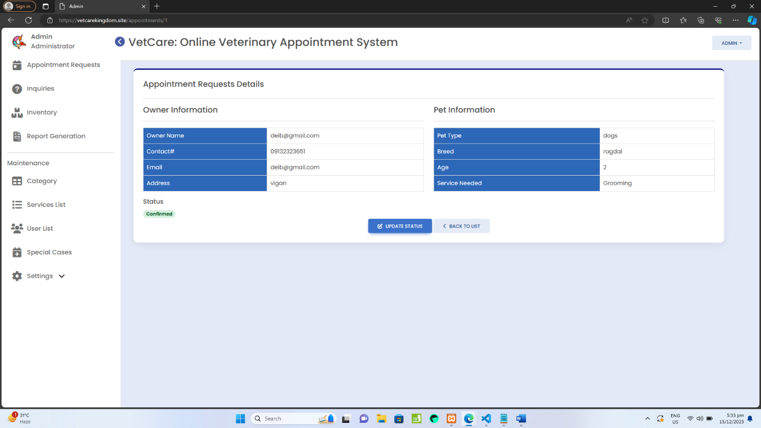

**Plate 2.1 Appointment Requests Details**

* **Update Status** – This **Modal Form** will appear once the Update Status button has been clicked. There will be a dropdown in updating the status where the admin can select whether Confirmed or Cancelled and by default the status will be Pending. Aside from that there is an input field for comment, and it is optional, it can be leave as blank. After that click the Save Changes to update the status.

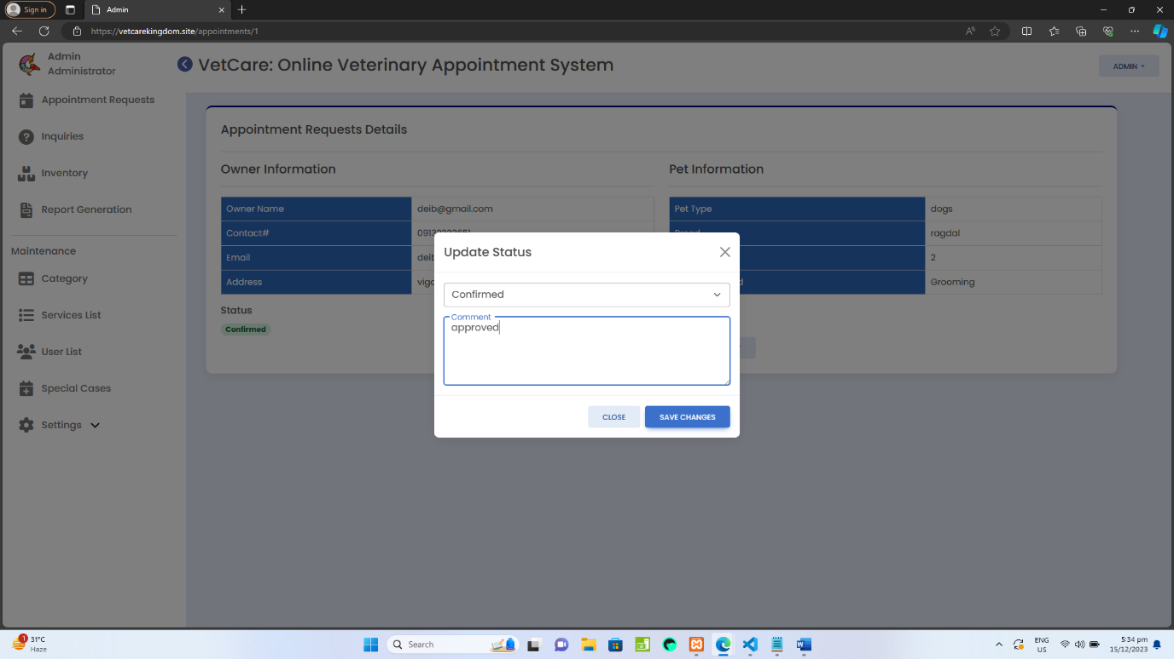

**Plate 2.2 Update Status**

1. **Inquiries page –** In this page, the admin will see the List of inquiries of the different clients/users who message them about their concerns or questions.
2. **View button** – If the admin wants to read the full message just click the View Icon button.
3. **Delete button** – If the admin wants to delete an inquiry just click the delete button.

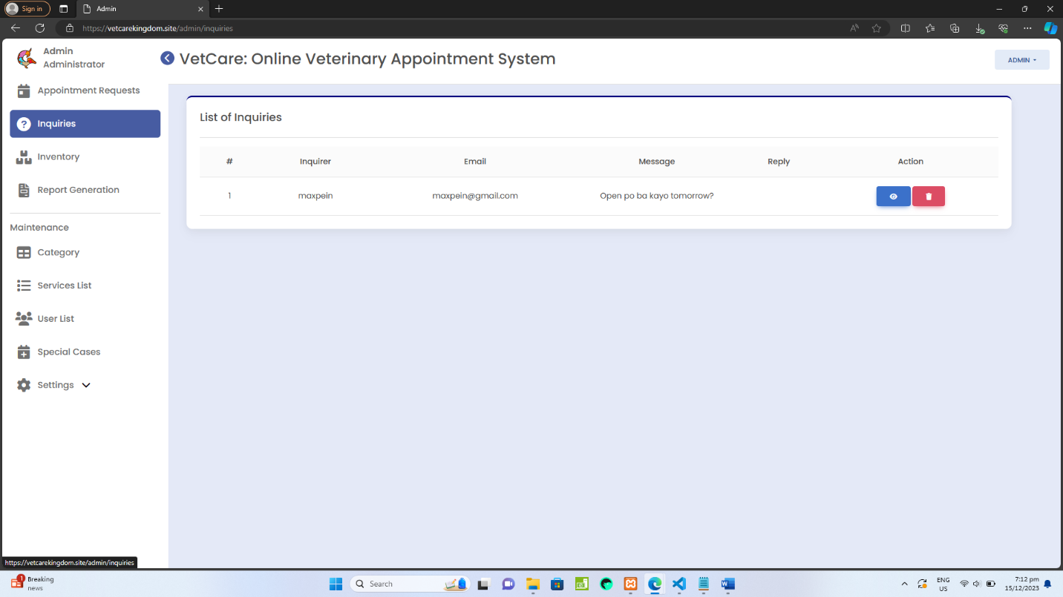

**Plate 3. Inquiries page**

1. **Inventory page –** This menu is where administrators can efficiently oversee and manage the stock of medications, supplies, and equipment within the veterinary clinic.
2. **TO ADD PRODUCT INFORMATION**

Step 1: Click the ADD PRODUCTS button.

Step 2: Fill up the information needed and add product image with jpeg,png,jpg,gif file formats only.

Step 3: Then, click SAVE button.

1. **TO UPDATE OR EDIT PRODUCT DETAILS**

Step 1: Click the Edit button and a modal form will show.

Step 2: Fill up the fields to update.

Step 3: Then click SAVE button to update the product details.

1. **TO DELETE A PRODUCT**

Step 1: Click DELETE button, once clicked there will be a confirmation message if the admin wants to delete the product.

Step 2: If yes, then click OK to permanently delete that product.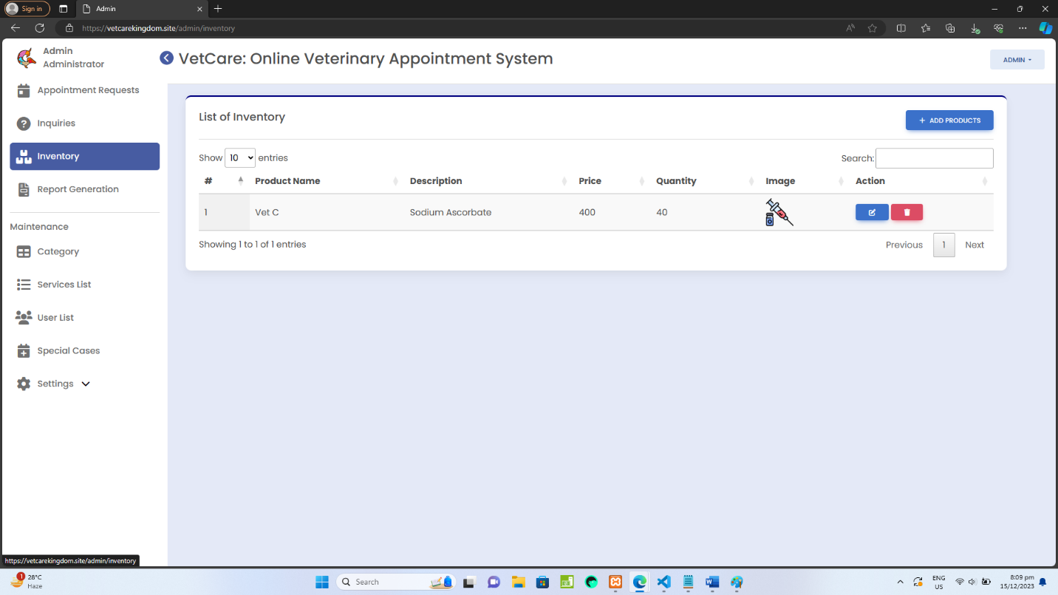

**Plate 4. Inventory Page**

1. **Report Generation page –** This menu allows administrators to generate a comprehensive list of appointments within a specified date range.
2. **TO GENERATE REPORT OF LIST OF APPOINTMENTS**

Step 1: Select Start Date and End Date

Step 2: Click the GENERATE REPORT button.

Step 3: Once the list of appointments has been generated and the admin wants to download it as PDF file just click the GENERATE PDF button.

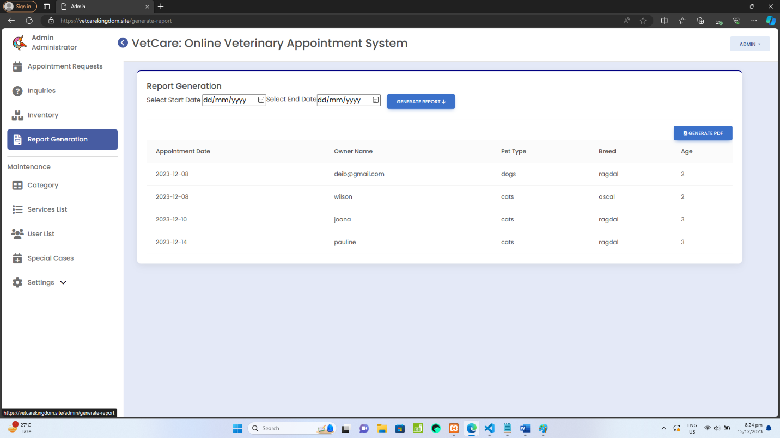

**Plate 5. Report Generation Page**

1. **Category –** This menu provides a structured and organized way for administrators to categorize different types of pets that users can select when scheduling veterinary appointments.
2. **TO ADD NEW CATEGORY**

Step 1: Click the ADD CATEGORY

Step 2: Fill out the field which is category name.

Step 3: After that click SAVE.

1. **TO EDIT OR UPDATE CATEGORY NAME**

Step 1: Click the EDIT button.

Step 2: Edit the category name being displayed in the field then click SAVE button.

1. **TO DELETE CATEGORY NAME**

Step 1: Click DELETE button.

Step 2: A confirmation message will prompt be asking if the admin wants to delete the category, if yes then click OK to permanently delete the category.

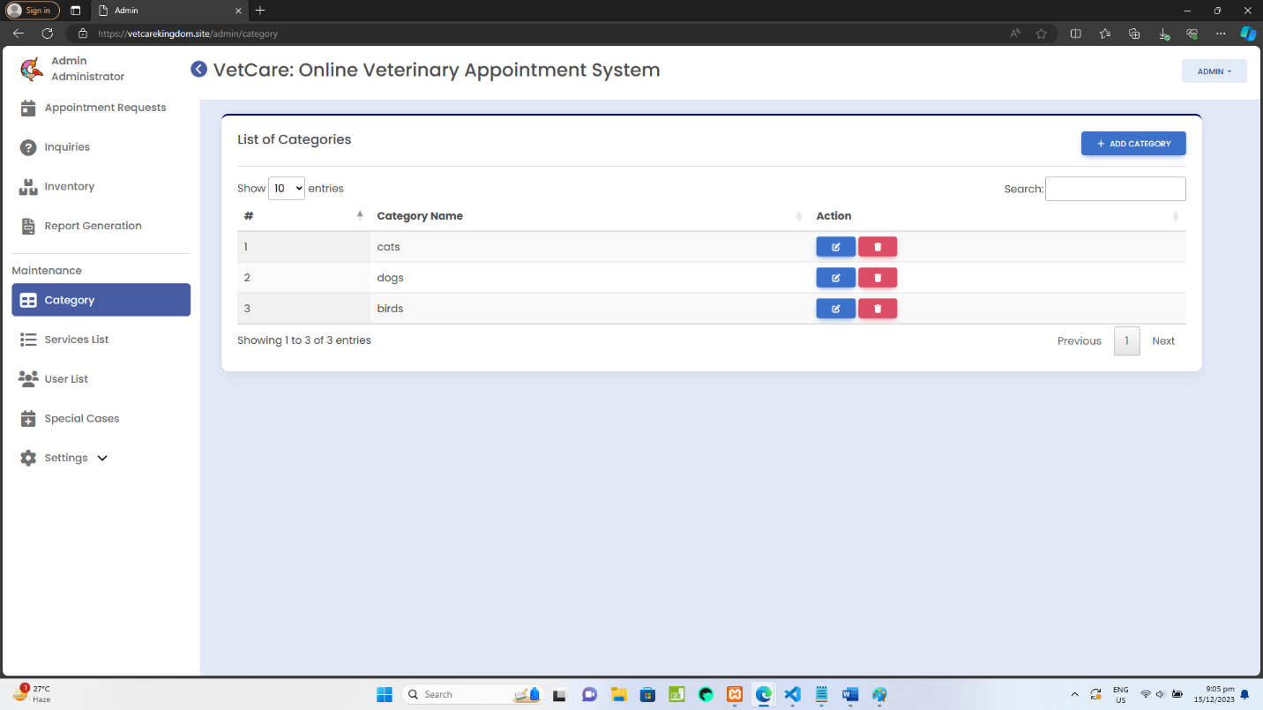

**Plate 6. Category Page**

1. **Service List** – This section allows administrators to manage and add new veterinary services that users can select when scheduling appointments for their pets.
2. **TO ADD SERVICE**

Step 1: Click the ADD SERVICES button.

Step 2: Fill out the fields such as service name, select pet type in the category dropdown and the price of service.

Step 3: Click SAVE button.

1. **TO EDIT OR UPDATE A SERVICE**

Step 1: Click the EDIT button and edit the details that needs to be updated such as service name and service fee.

1. **TO DELETE A SERVICE**

Step 1: Click the delete button.

Step 2: A confirmation message will prompt be asking if the admin wants to delete the service, if yes then click OK to permanently delete the service.

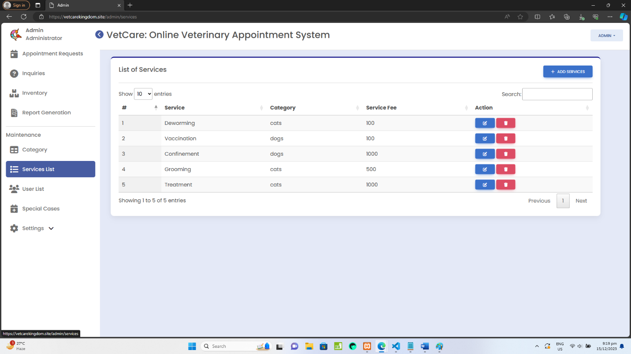

**Plate 7. Service List**

1. **User List** – The User List page provides administrators with an overview of registered users within the veterinary system. It allows for efficient user management, ensuring accurate records. The admin can see the list of users or clients registered on the website. The admin can also edit and delete a user by clicking the buttons under the Action column.

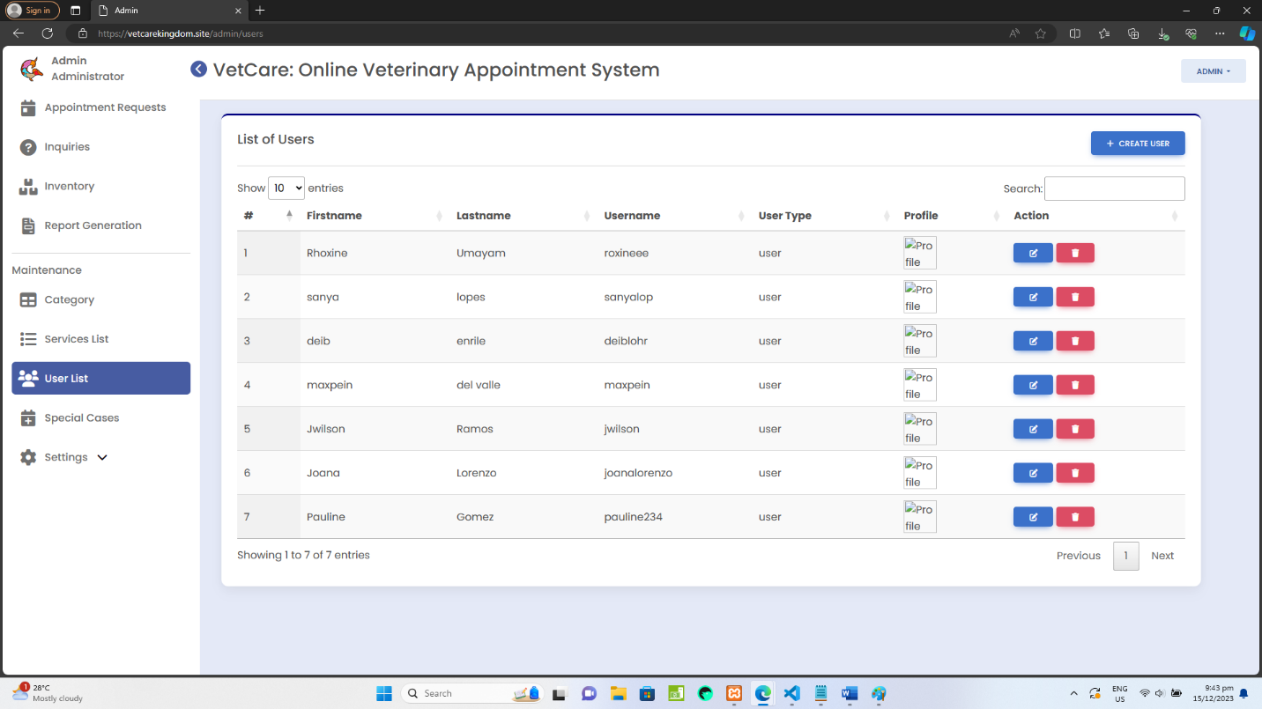

**Plate 8. User List Page**

1. **Special Cases** – This section provides guidance on identifying and managing Special Cases effectively. This section is to handle walk-in clients with emergency cases that requires immediate attention and swift action.
2. **TO ADD NEW CASES FOR WALK IN CLIENTS**

Step 1: Click ADD NEW CASES button.

Step 2: A modal form will show and fill out the fields such as owner name, pet name, age, pet type, and select a service from the dropdown.

Step 3: Click SAVE button.

1. **TO EDIT OR UPDATE INFORMATION**

Step 1: Click the EDIT button.

Step 2: Edit the necessary information that needs to be updated.

Step 3: After that, click SAVE button.

1. **TO DELETE A CASE**

Step 1: Click the delete button.

Step 2: A confirmation message will prompt be asking if the admin wants to delete

the case, if yes then click OK to permanently delete the case.

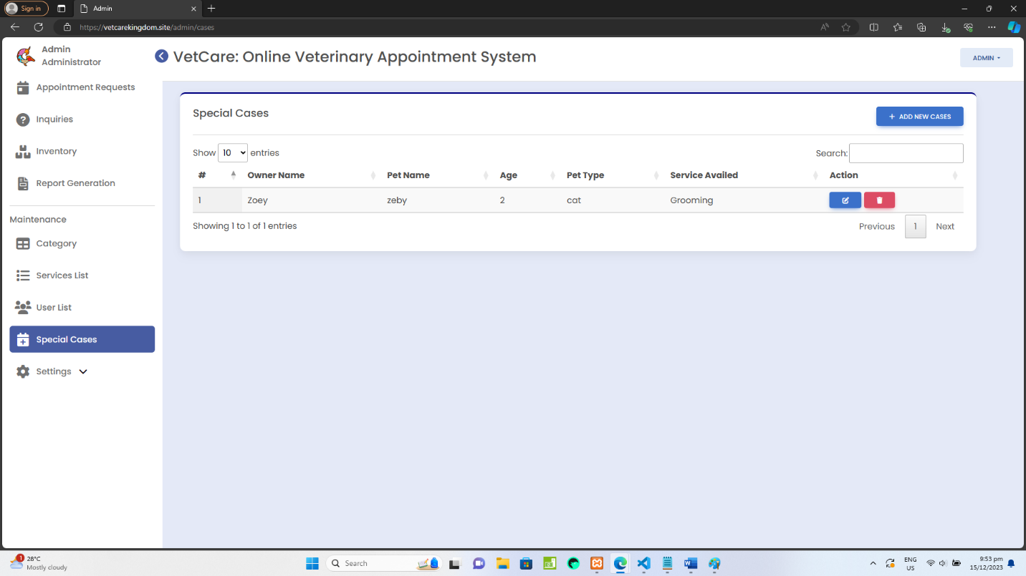

**Plate 9. Special Cases Page**

1. **Settings –** Under the Settings menu there are two sub-menu which are the Services Management and Footer Management. It is intended to manage the contents of the website to be seen by the users/ clients who will access the website.
2. **Services Management** – In this sub-menu the admin can ADD, EDIT and DELETE the service information that will be displayed on the client side.

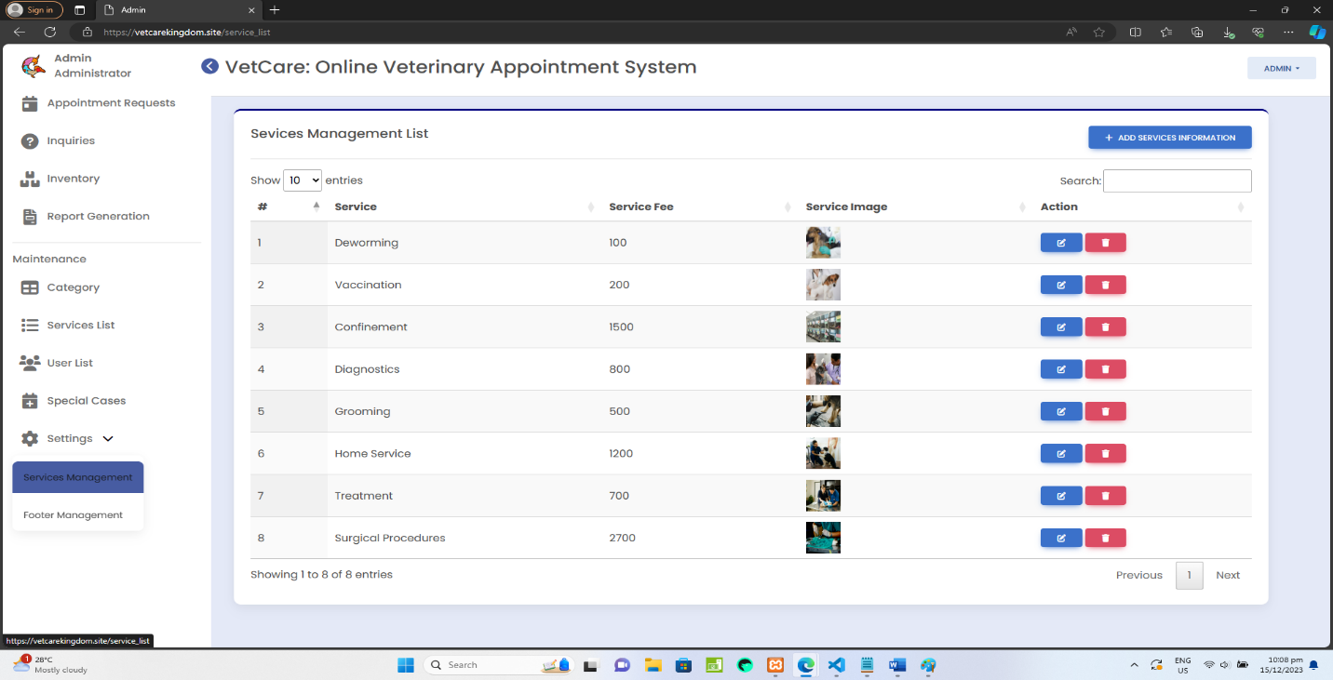

**Plate 10. Settings (Services Management)**

1. **Footer Management** – In this sub-menu the admin can ADD only one record for footer information and the admin can also EDIT the footer information that will be displayed on the client side.

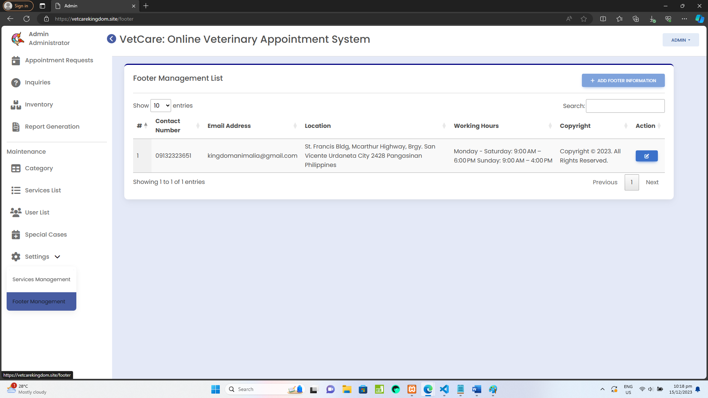

**Plate 10.1 Settings (Footer Management)**

**Client Side**

**Registration –** User registration is a crucial step for individuals to access the features and services of the online veterinary system. This process ensures that the system has accurate information about users and allows for personalized interactions. If the user has no account yet, they need to register first by filling out the fields. When done, click the **SIGN-UP** button and the user will be directed to **Login Page.**

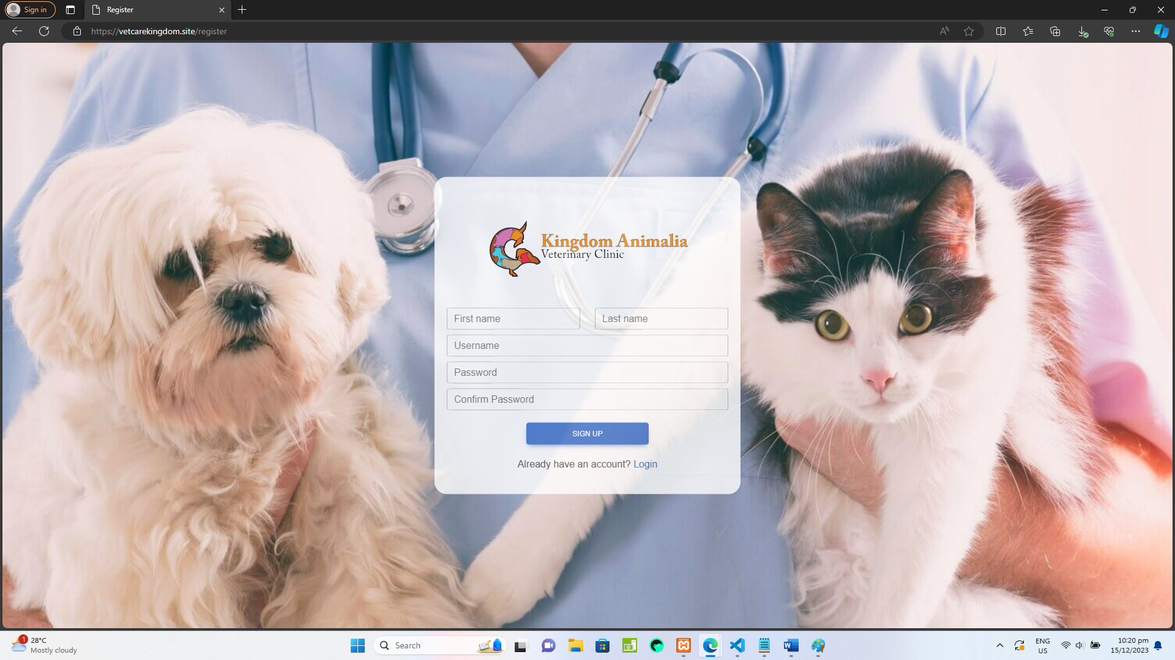

**Plate 11.** **Registration page**

**Homepage –** Once the user logged in, this is the HOMEPAGE where the user will direct.

* On the navbar there are different menus including the HOME, APPOINTMENT, CONTACTS US, and ABOUT US.
* The name of the currently logged in user is displayed in the dropdown menu. And there is sub-menu under the dropdown menu which are **My Appointment** page and **Logout** button.

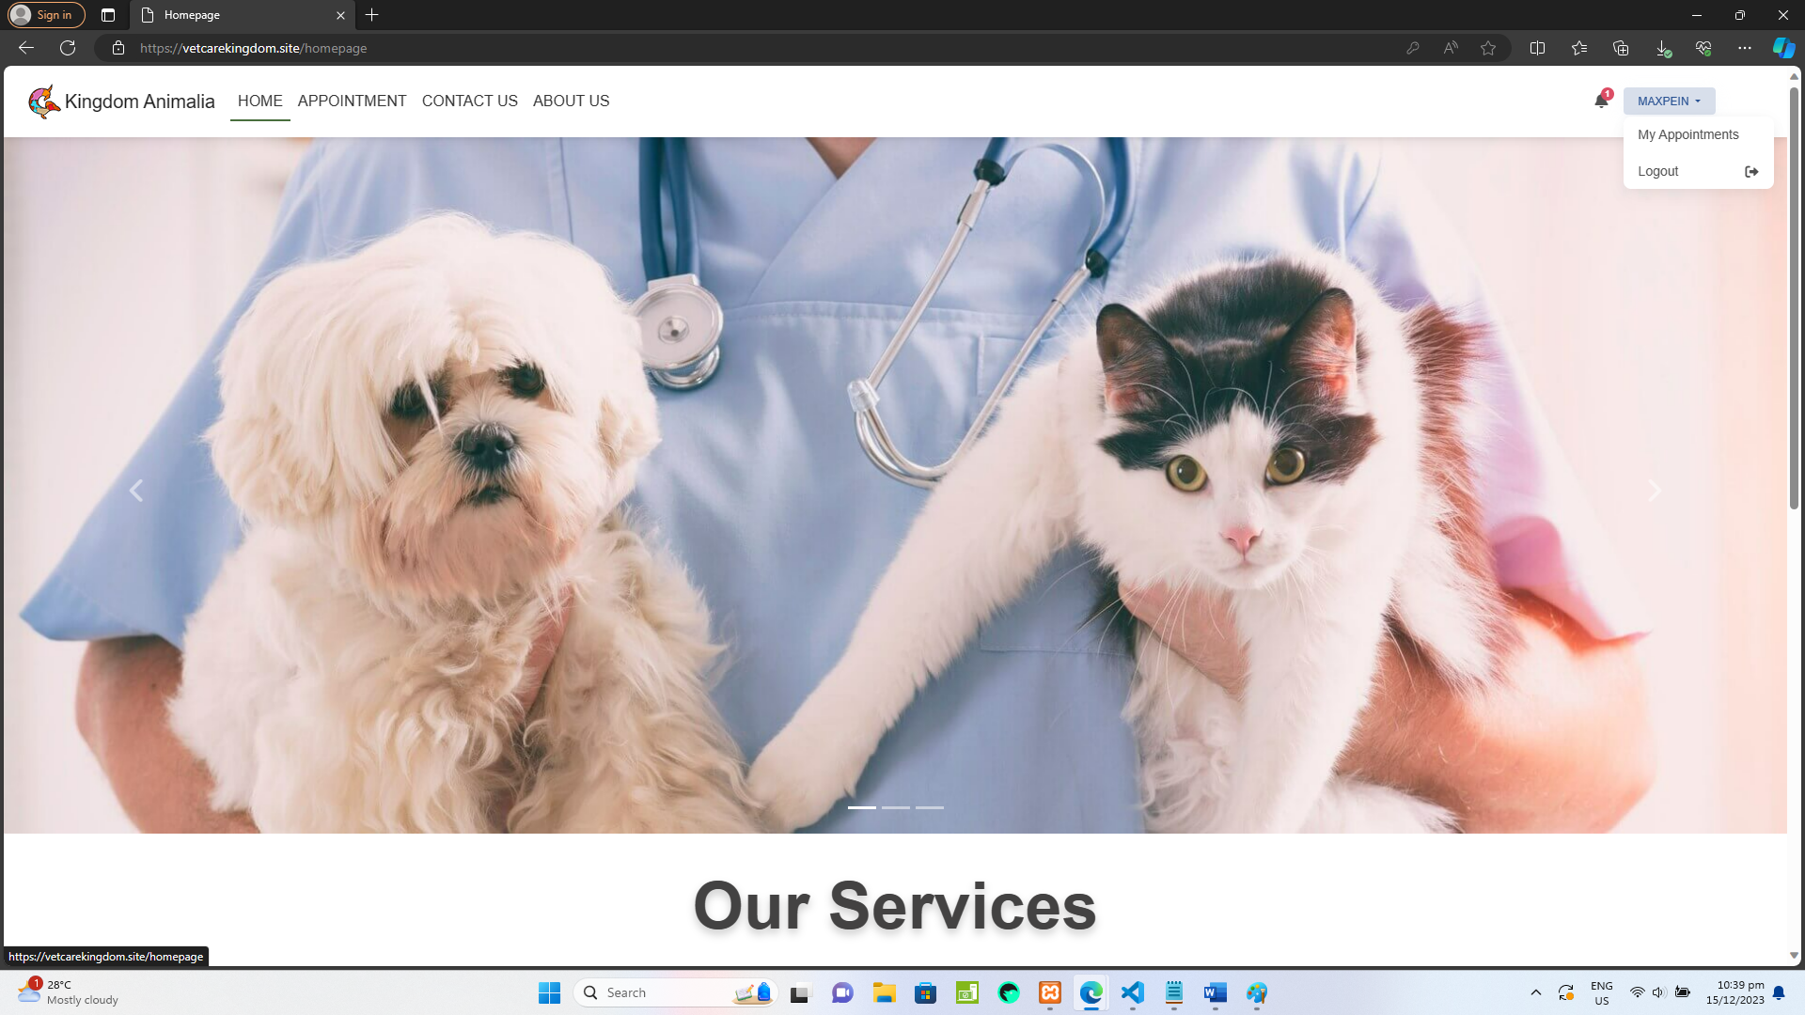

**Plate 12: Homepage**

**Appointment page –** The appointment page for clients is designed to facilitate the scheduling and management of veterinary appointments for their pets.

* TO SET AN APPOINTMENT

Step 1: Click blue **BOOK** button for available date to set an appointment. Once clicked, a modal form will appear.

Step 2: Fill the form with required information which includes *owner information’s* such as owner name, contact number, email address, address. For *pet information*, it includes selecting of pet type, breed, pet age, and selecting a service.

Step 3: Click **BOOK APPOINTMENT** button to save appointment schedule.

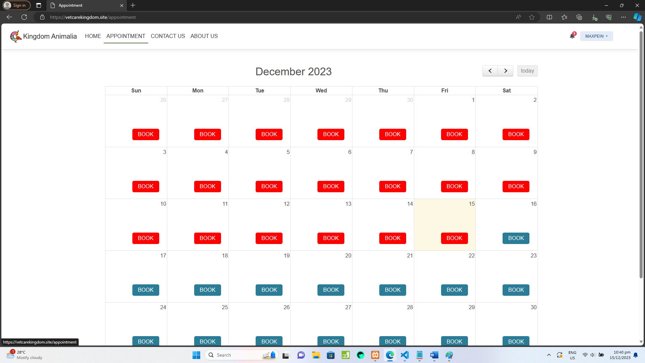

**Plate 13: Appointment page**

**Contact Us page –** The contact page is designed to facilitate communication between users and the veterinary clinic. Whether users have inquiries, need support, or want to provide feedback, the contact page is the central hub for reaching out to the clinic.

* To send inquiries just fill out the fields such as name, email address, and message or queries. After that click **SEND** button.

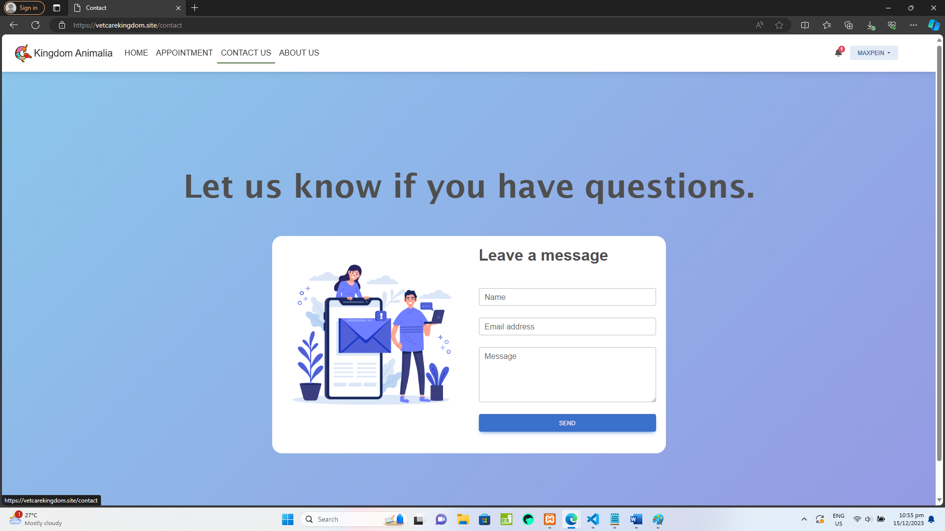

**Plate 14: Contact Us page**

**About Us page –** The About Us page serves as a window into the veterinary clinic's identity, values, and team.

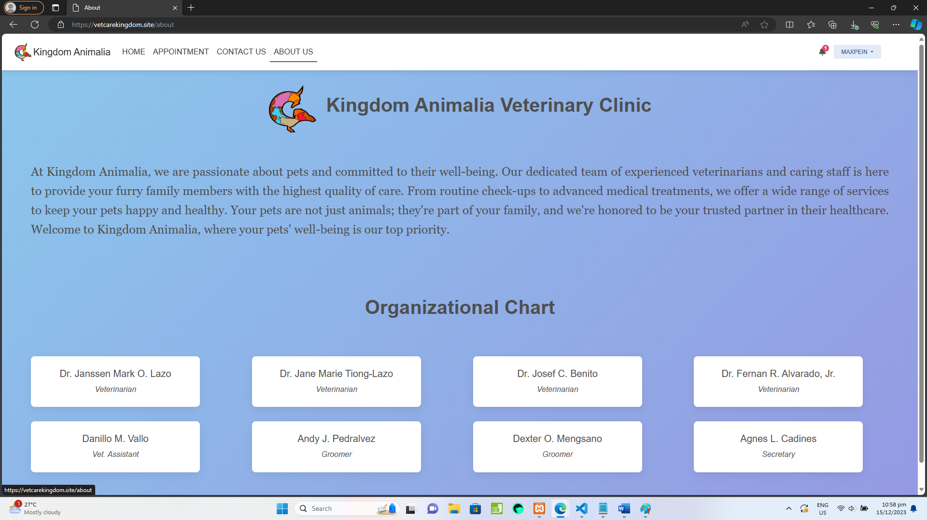

**Plate 15: About Us page**

**My Appointment page –** This page is a crucial section for users to manage their scheduled appointments, view appointments if the status is Confirmed or Cancelled.

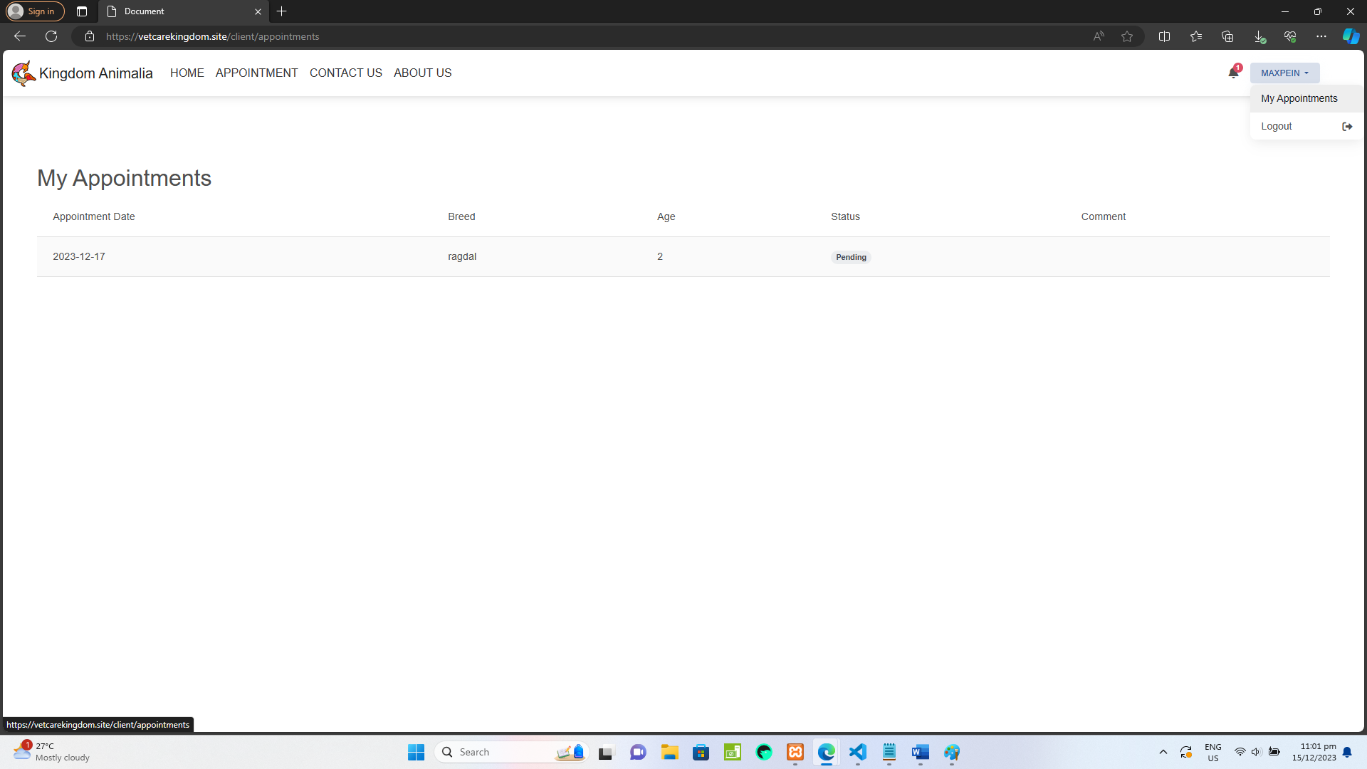

**Plate 16: My Appointment page**